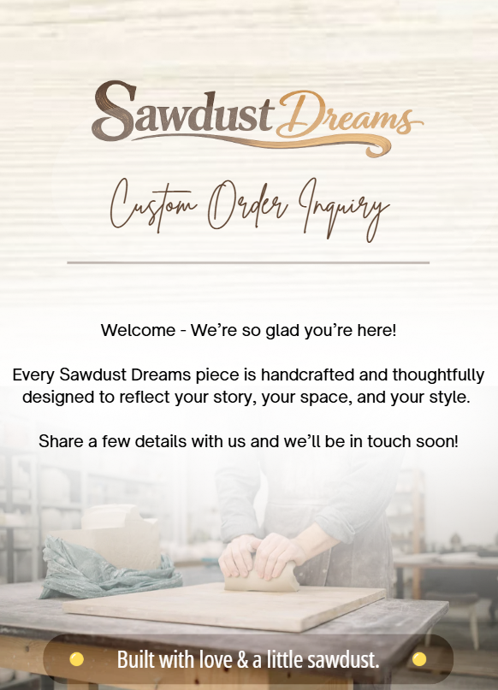

YOUR INFORMATION
Name: __________________________________________________________________
Email Address: ___________________________________________________________
Phone Number: __________________________________________________________
Preferred Contact: ☐ Email ☐ Text ☐ Phone

TELL US ABOUT YOUR PROJECT
☐Custom Sign ☐Home Décor ☐Furniture ☐Gift
☐Other
Describe Your Vision: ______________________________________________________
________________________________________________________________________
________________________________________________________________________

PROJECT DETAILS
☐Birthday ☐Wedding Gift ☐Housewarming ☐Closing Gift
☐Memorial Piece ☐Cutting Board ☐Other: ________________
Desired Completion Date: ____________________

MATERIAL SELECTION
☐Wood ☐Plastic ☐Acrylic ☐Other: ____________
Preferred Wood Type (if applicable):
☐ White Oak ☐ Walnut ☐ Maple ☐ Cherry
☐ Teak ☐ Pine ☐ Black Walnut
☐ Other: ______________
☐ Not Sure — Open to Recommendation

Finish / Color Preference (if applicable): ________________________________________________________________________

SIZE & DIMENSIONS
Do you have a specific size in mind?
☐ Yes ☐ No
If yes, please provide dimensions:
Width: __________ Height: __________ Depth: __________
If not, select a general size range:
☐ Small (under 12")
☐ Medium (12"–24")
☐ Large (24"+)
☐ Not sure — need guidance
Where will this piece live?
☐Indoor ☐Outdoor
☐Wall ☐Tabletop ☐Office ☐Other: ________________

PERSONALIZATION
Would you like customization? ☐ Yes ☐ No
If yes, please describe in detail. Provide any names, dates, etc:
________________________________________________________________________________________________________________________________________________________________________________________________________________________________________________________________________________________________________________________________________________________________________________________________________________________________________________

INSPO PHOTOS
If you have attachments or inspiration photos you would like to send our way, please email to info@sawdustdreams.com.

DELIVERY
☐ Local Pickup (Orlando, near Universal) ☐ Local Delivery ☐ Shipping
Address (to Ship or Deliver): ________________________________________________________________________

BEFORE YOU SUBMIT
- Pricing / Quote to be supplied based on size, material, & detail.
- A mock up representation will be supplied before any work is started.
- Deposit may be required depending on project size.
- Lead times vary based on projects.
- Custom pieces are final sale.
